**How do we split numerical features?**

Since in numerical feature there are continuous variable so do we split them.

Note: we can use Gini entropy for this too.

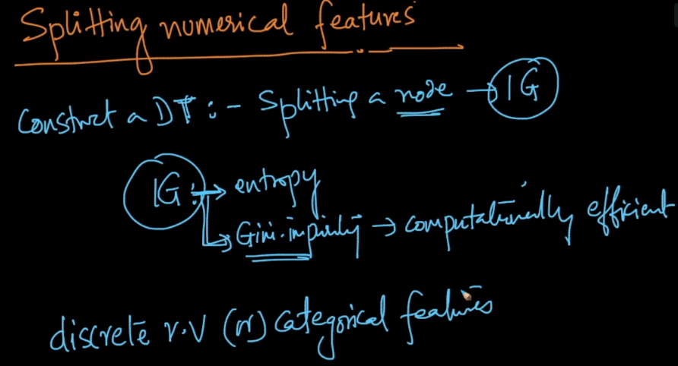

**Procedure for splitting numerical feature:**

1. Sort the numerical feature in ascending order.
2. Now take the threshold as the value at position 1 to split, such that value <= t1.
3. Check the information gain obtained using this threshold.
4. Now take the second value as threshold ie decision node is value <= t2.
5. Again check the information gain for this threshold.
6. Suppose we have ‘n’ numerical values, so repeat this procedure for all ‘n’ values
7. So finally we pick that value as threshold whose information gain is maximum.

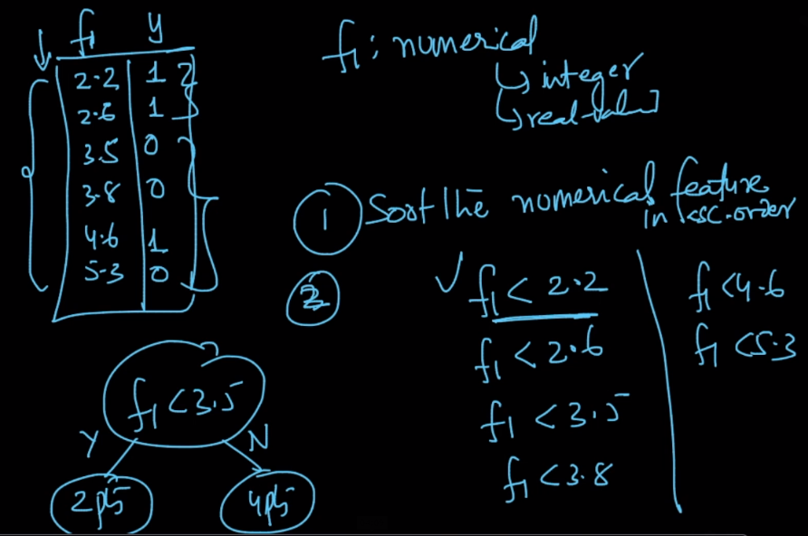

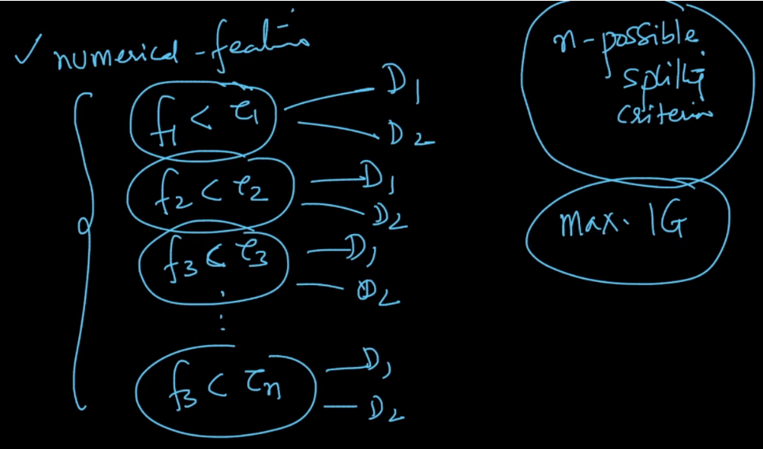

**How to construct DT when we have numerical value as output ie regression.**

<https://www.saedsayad.com/decision_tree_reg.htm>

**Can I set depth of tree more than no. of features.**

